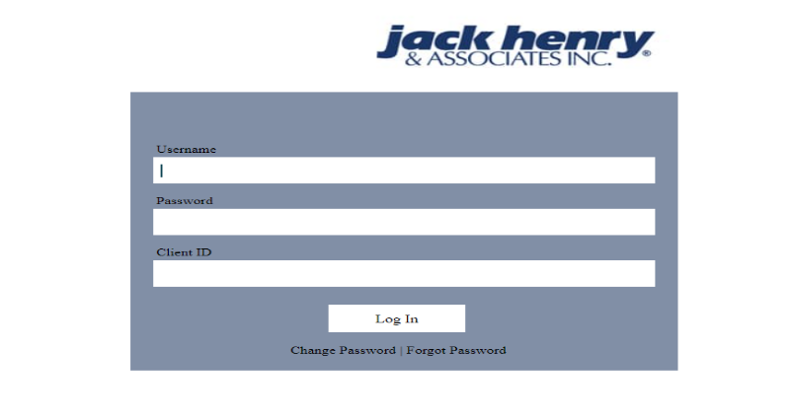
Log On:
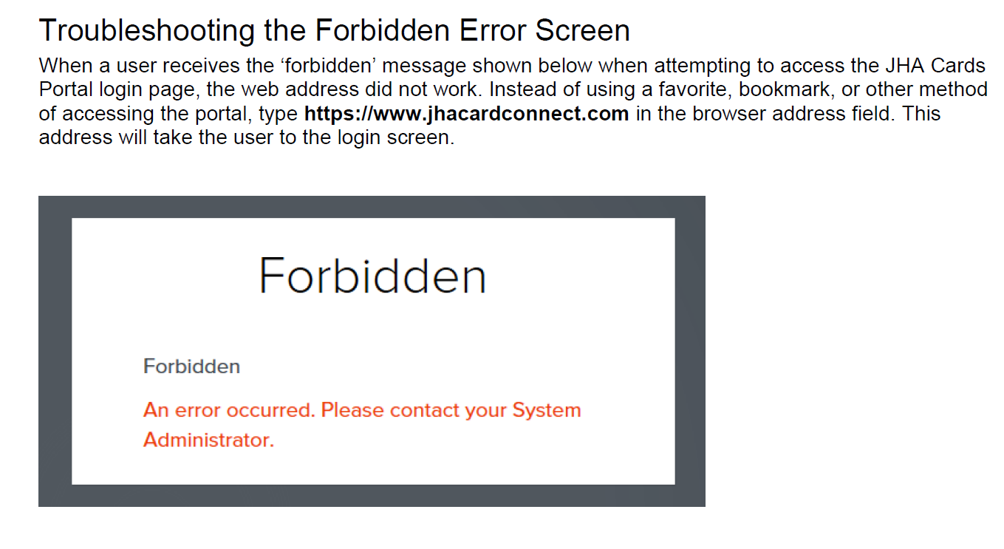
Log On to QuickAssist through JHA Cards Portal via single sign-on. Once you gain access, you may search for an account within QuickAssist.
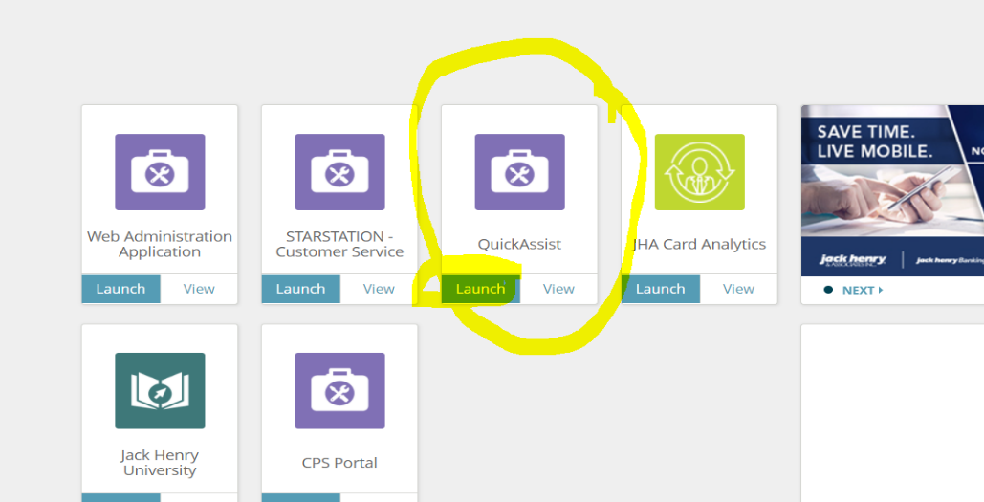
LAUNCH QUICKASSIST

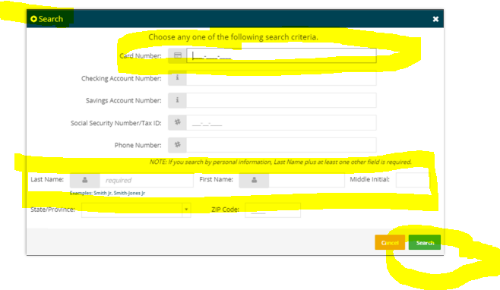
Cardholder Account Search
The Cardholder Search widget appears when the user first logs on to QuickAssist.
Search Members card by entering either the FULL CARD NUMBER or MEMBER NAME.

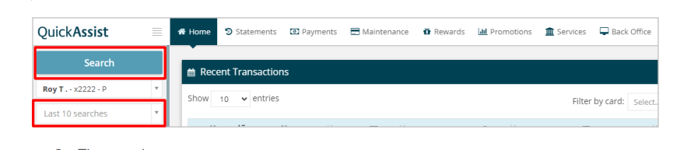
To make another SEARCH:
On the HOME tab, click SEARCH located in the upper left corner.
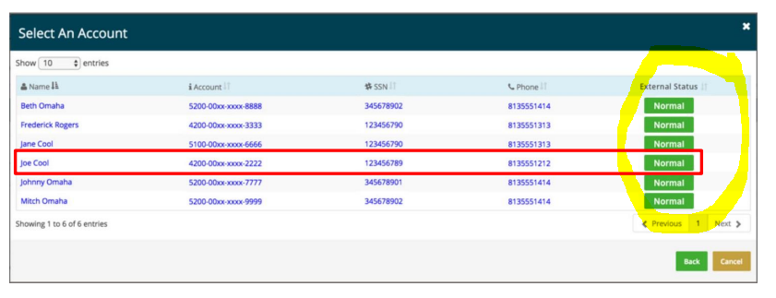
If the search returns with more than once account, click the desired account. The account information appears.

The external status codes can be any of the following:
• Normal
• Authorization Prohibited
• Closed
• Lost
• Fraud
Use Back to return to the search criteria entry screen or use Cancel to cancel the search.

***keep scrolling more instructions*****
Home Tab Overview 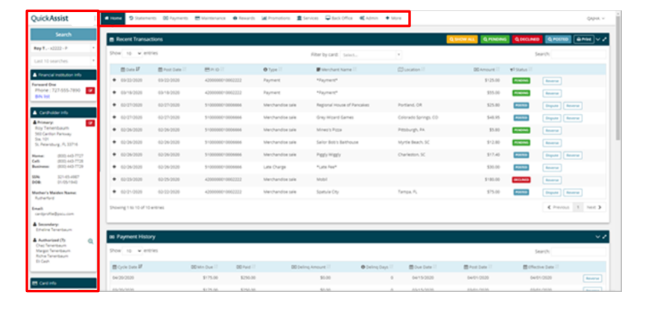Tabs are the top of the page. These take users to functions or information on the card record. The FI administrator assigns the tabs that each QuickAssist user needs.
The following tabs are available:
• Home
• Statements
• Payments
• Maintenance
• Rewards
• Promotions
• Services
• Back Office
The left pane includes the following functions:
• Search: Allows users to search for a card record
• Financial Institution Info: Provides phone number and BIN list
• Cardholder Info: Provides cardholder’s contact information
• Card Info: Provides basic card information such as status, expiration date and associated checking or savings accounts
Card Info
On the Home tab, in the left navigation, the Card Info section contains information pertaining to the card itself.
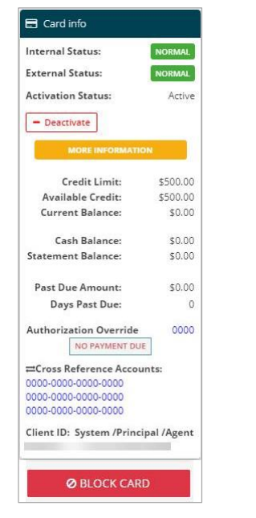
Fields include:
• Internal Status: Status the system assigned when account meets specific criteria; this status is not added by a person.
o Normal
o Credit Balance (N)
o Delinquent (D)
o Over limit (O)
o Delinquent and Over limit (X)
• External Status: Status added by a person. There are different ways for an external status code to be added to an account, but these statuses block the card from being used.
o Normal
o Authorization Prohibited (A): Temporary block placed on the account. The most common reason is the Fraud Team is researching fraud activity.
o Bankrupt (B): Customer filed bankruptcy.
o Charge Off (Z): Customer is not making payments and financial institution has determined card should not be part of their good loans.
o Closed (C): Based off a customer request. (Closed by Consumer)
o Frozen (F) o Interest Accrual Prohibited (I): Stops interest and fees from posting to the account. Commonly used as a pre-charge off status so the last statement balance is the final balance. Used to determine amount for charge off approval to board or management, if applicable.
o Lost (L)
o Revoked (E): The financial institution closed the card. (Closed by Grantor)
o Fraud (U)
***Highlighted in yellow is what YOU normally will see in JHA QUICKASSIST****

Transactions
This section covers transactions. It describes how you view posted transactions and pending authorizations on a cardholder’s account.
Posted Transactions:
The Posted Transactions widget allows you to view the details of posted transactions. It also is where you dispute a transaction. Access this widget on either the Home or Statements tab.
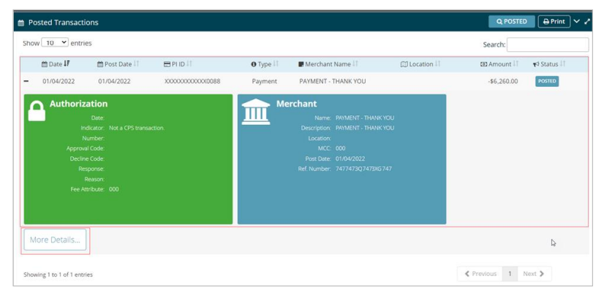
Transactions are listed in reverse chronological order beginning with the most recent one.
Information for each transaction is organized into these columns. Click a column header to sort transactions in ascending or descending order.
• Date • Postdate • PI ID (Plastic ID) • Type • Merchant name • Location • Amount • Status
The Status field indicates that the transaction posted.
The More Details button displays the Transaction Detail screen which contains the Authorization Date and Authorization Time.
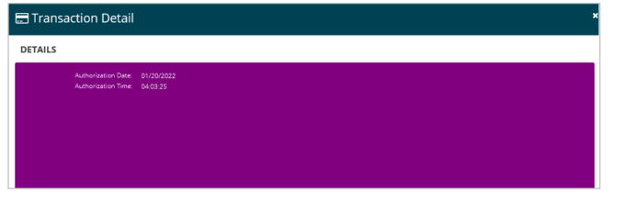
Follow these steps to locate a posted transaction.
1. Select the Home tab or the Statements tab.
2. Locate the Posted Transactions widget.
3. Scroll through the transaction list or enter one of the following types of information in the Search field to locate a specific transaction:
• Date • Postdate • PI ID (Plastic ID) • Type • Merchant name • Location • Amount • Status
4. Click the (+) plus sign on the far left side of the transaction row to open the Authorization and Merchant details tiles. Click the (-) minus sign to collapse the row.
NOTE When more than 500 transactions exist on a statement, or since the last statement cycle, users can select the More button to display the additional transactions.

Pending Authorizations
The Pending Authorizations widget allows you to view the details of pending authorizations. Access this widget on either the Home or Statements tab.
The Pending Authorizations widget enables you to view:
• pending authorizations on a cardholder’s account.
• declined transactions on a cardholder’s account.
• reversed transactions on a cardholder’s account.
Information on this widget includes:
• details for declined, pending, and card present transactions
• the date and time of the authorization
• when applicable, the auth expiration date that was entered at the time of the transaction.
The timestamp appears in 24-hour format (Central Time) and is helpful in situations where the exact time the transaction occurred is needed. The expiration date is helpful in situations such as when an authorization is declined due to an invalid expiration date being entered.
***keep scrolling more instructions*****
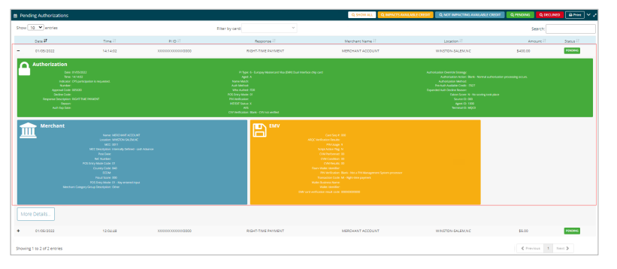
Use the (+) plus sign to expand any given transaction row to see additional details regarding each transaction. The row expands to show Authorization and Merchant details.
Use the (-) minus sign to collapse the transaction information.
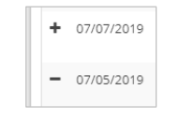
Use the More Details button to view the Transaction Details screen which contains the Authorization Date and Authorization Time. Use the Previous or Next navigation buttons at the bottom to move to a specific page of transactions.
You may view all transactions or filter them by these selections:
• Impacts Available Credit • Not Impacting Available Credit • Pending • Declined
The filter is selected when the button is a solid white background with text in color, as shown in the lower line of the graphic.
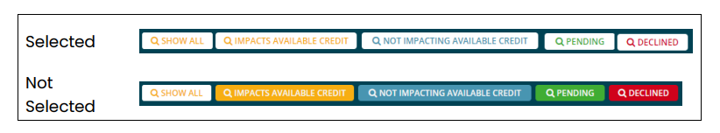

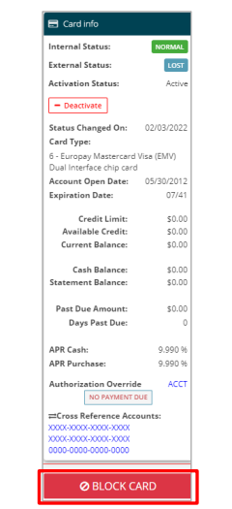
Block Card
Follow these steps to put a block on a card.
- On the Card Info widget, click the Block Card button.
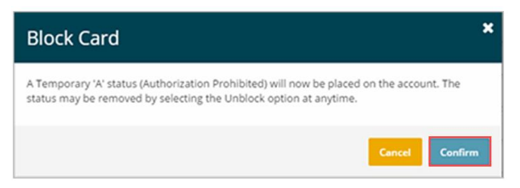
- . Click the Confirm button.
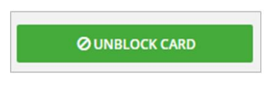
The BLOCK CARD CHANGES to UNBLOCK CARD displayed in GREEN.

Unblock Card
The Block/Unblock Card takes place on the specific card accessed. If there are multiple cards which need to be unblocked, access each card to unblock the card. Follow these steps to unblock a card.
- On the Card Info section, click the Unblock Card button.
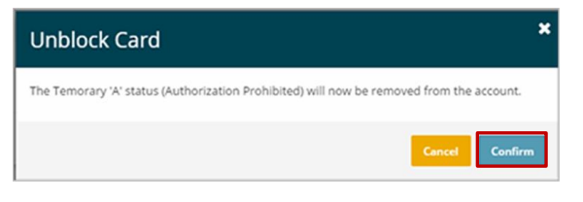
- Click the Confirm button.
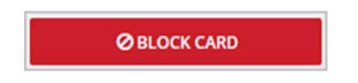
The Unblock Card changes to Block Card displayed in red.

UPDATE CARDHOLDER INFORMATION:
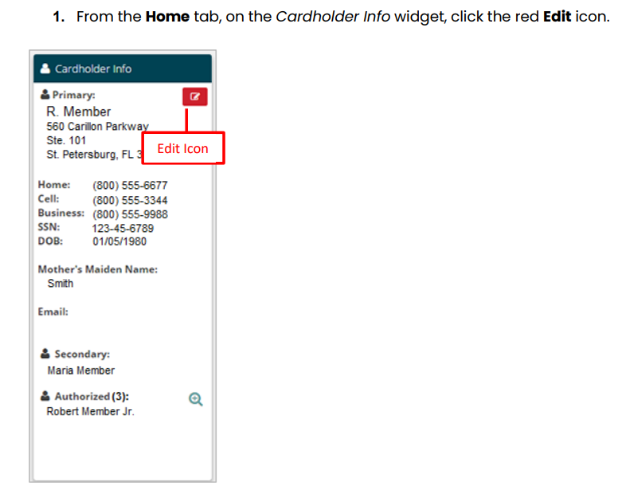
The following information for primary cardholder can be updated:
• Type
• Name
• SSN
• DOB
• Mother’s Maiden Name
• Credit Bureau Reporting
Follow these steps to update the primary cardholder’s info.

The EDIT ACCOUNT USER widget appears:
1. From the HOME tab, on the Cardholder INFO WIDGET, click the RED EDIT ICON.
2. Select the cardholder type from the Type drop-down menu.
3. Make the required changes on the Cardholder Info tab.
4. Click the Confirm button

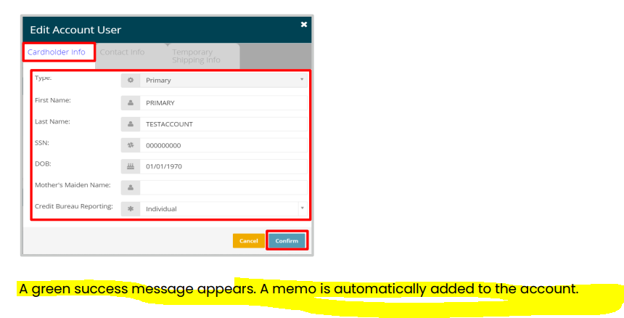

UPDATE CONTACT INFORMATION:
The following information for primary cardholder can be updated:
• Street
• Street 2
• City
• State
• Zip
• Country
• Home Phone
• Cell Phone
• Work Phone
• Email (NEEDS TO BE IN ALL CAPS EXAMPLE: EABELLA@TONGASSFCU.COM)
Follow these steps to update the primary cardholder’s info.
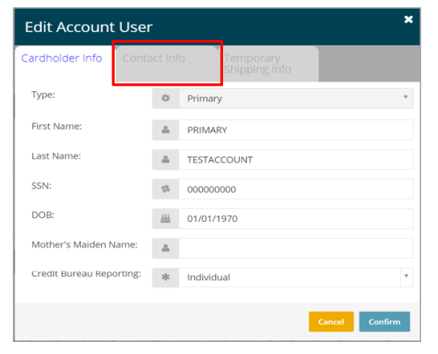
- From the Home tab, on the Cardholder Info widget, click the red Edit icon. The Edit Account User widget appears.
- Click the Contact Info tab.

- Make the required
changes on the Contact Info tab.
• When adding a new or changing an existing address, you may have the system perform address validation or bypass the address validation.
• The Valid Bypass field defaults to Y – Do not bypass the address validation.
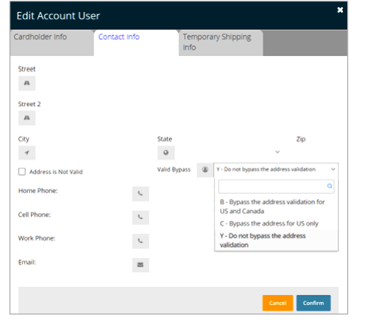
Select the appropriate option to bypass:
o B – Bypass the address validation for US and Canada
o C – Bypass the address for US only

NOTE The system defaults to Y whenever any changes are made to the address. Select an option to bypass address validation.

- Click the Confirm button.
- A green success message appears. A memo is automatically added to the account.

Reset PIN Attempts

The widget displays the PIN tries and a note to the user. Use the following steps to reset the PIN attempts.
CAUTION
If the card’s external status is not Blank or Authorization Prohibited, PIN attempts cannot be reset.

Follow these steps to reset PIN attempts.
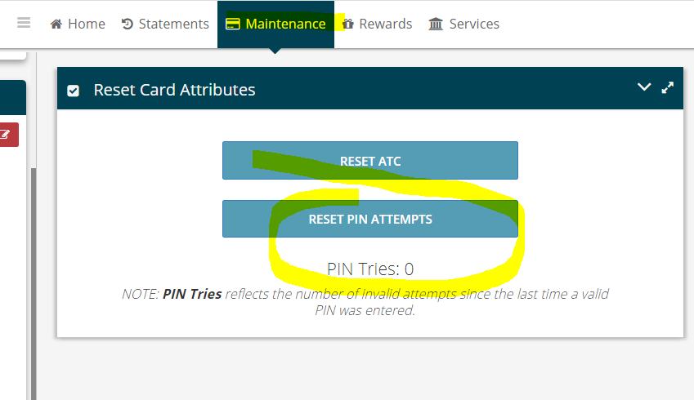
- Maintenance TAB
- Click the Reset PIN Attempts button.

A green success message appears, and the PIN Tries resets to zero.

NOTE PIN Tries reflects the number of invalid attempts since the last time an invalid PIN entered.

